V8T.V VMS Solution / MVP Solution Feedback / September 6, 2026 / R Duguay
GP Portal / GP Admin
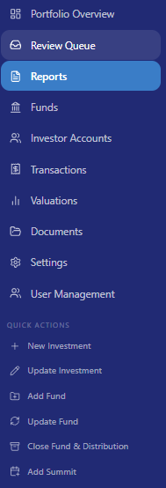 | Reports: We could change this Section name to ‘Company Reports’ as this is the area where we are doing requests, review, and approvals for posting to record.
As I was looking at the Menu, it struck me that we should probably also have a Menu Item: Companies

I do see a means to ‘Add Company’ on the Portfolio page, but it would be perhaps intuitively positive to also have an added Menu Item that is specific to companies only.

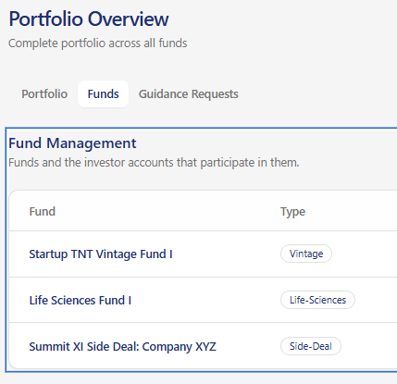 | On the Portfolio Overview page, regarding ‘Funds’ can you make the names of the funds something that includes a hover box, and could be clickable to go to the Funds screen for further review… like the ‘Company’ box we could have a ‘Fund View’ and ‘Edit’ buttons at the top as options.

Portfolio Overview
Portfolio Overview screen | There is a section (top button) regarding Founder requests, but another button (add-on) could be a Chat (or Messages) section where Founders, or LPs could interact privately with GPs, or similarly GP Admins.
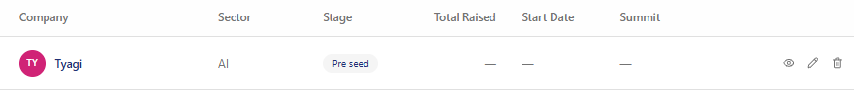
For this list screen. Good execution on list. | Feature add: Could we add in another column for ‘Last Valuation’ and ‘As of date’ reference.  For the Fields for Company, for each of the ‘Company’ names… could we indicate a hyperlink with underline so that there is an intuitive idea that companies can be found through the hover box (already indicated)… I like the hover box with ability to ‘View Full Profile’
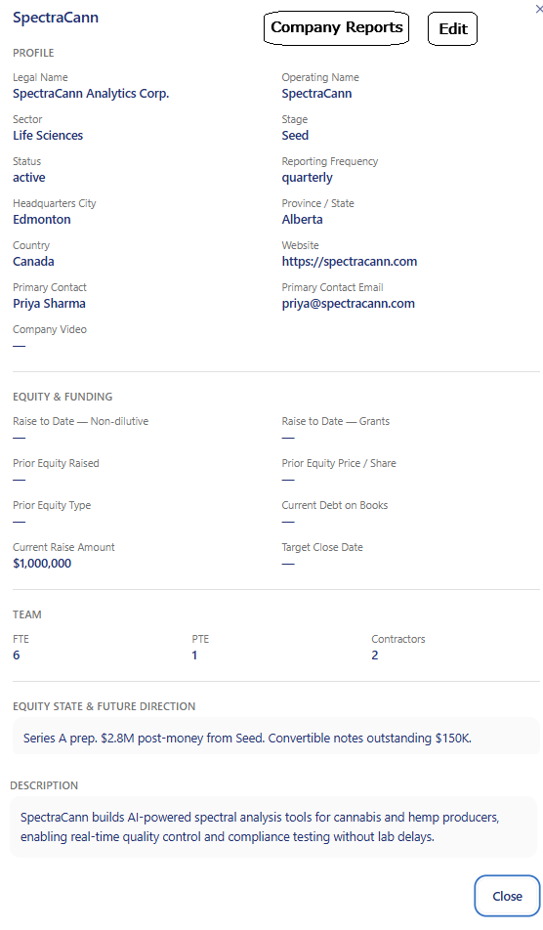 | On the Company box, following View Full Profile:  - Could you add a couple buttons per image, (1) Company Reports, that takes us to that Company Reports screen, and (2) Edit, which would provide a means of editing the Company; this being provided for GP Admins only… The Company Reports button could be provided to associated GP, LP and Admins.  - Under the PROFILE Section, I would like a field for ‘Simplified Data Room’ where we will make it possible to add a link to a Dropbox… which we will manage.  - I am thinking that we may want to add a unique Menu Item section in the VMS Application relating to Datarooms… but let’s discuss this idea before addressing.  - I would like a section following ‘EQUITY & FUNDING’ which would be titled ‘VALUATION’ with fields from latest Valuation (details)  - it makes this box a bit bigger, so maybe we need a scroll bar as well here.

Transaction / Transaction Type:
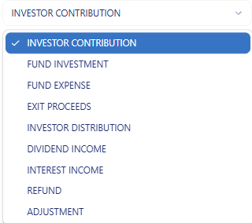 | Transactions: I like this section but I think it is a bit un-intuitive regarding the ‘Transaction Types’… which presents under the ‘Record Transaction’ dropdown…  What I am thinking could be easier for people (GP Admins, mostly)… is that for each ‘Transaction Type’ once it is selected (from the drop-down box), we provide an ‘Information box’ which provides a description of the Transaction, and how it should be applied…
Payment method: | I think we should add an ‘Other’ in the dropdown, and then present an open text field to fill in.

Documents Menu:
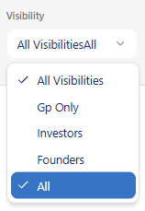 | There is a minor glitch here in this dropdown… there should just be one item… probably indicate ‘All Roles’ and delete ‘All’

General Items:
URL Add | I am thinking we would use the name of ‘Value Management System’… so would like to also have the URL: vms.vital8t.ventures  … in addition to the current valuehub.vital8t.ventures URL
Migration to Canada Servers | Per earlier notes, please migrate the hosting location to Canada (currently in US).
Terms of Service & Privacy Policy | Laura & I can collaborate on creating these content pieces which will be needed before we onboard anyone.
Process Workflows: User Guidelines | Laura & I will collaborate on creating some basic workflow guides and associated one-pager type files for each of the roles:  - GP Admin  - GP / Investor  - LP / Investor  - Founder
NEW: Sept 10, 2026  * Create Icon for Browser Tabs (i.e. Chrome) | Currently browser tab is showing a Lovable Icon, and would be better to have a V8TV Icon as the image. Idea:  
NEW: Sept 10, 2026  Founder  Admin / GP Admins | Founders should only be able to see and edit and respond to their Reports… the current Founder test ID shows multiple company reports… so we will need to create and test accounts that are specific to companies that they are associated with.  Overview: Founder Screen: We need to have Founder linked to one company (per login) / similar to how other kinds of accounts work… Companies should have a unique ID.  Edit User: For Founders, we need to be able to associate Founders to Companies (that exist)… so when an Invite is sent (following Company creation) – we need to have that Founder specifically associate with the Company they are assigned to.  Linking Companies to User ID: We need a method for assigning User IDs to companies. We should limit the total number of IDs that can link to a Company (as Founders, to no more than 3 ID)
Need a walkthrough of ID (Founder) ID Setup and Linking to Company ID | I got an error when I used my V8T.V email ID, but that might be because this email is assigned??

Feedback file drafted September 6, 2026 / Version 1.0 / Randy Duguay / V8T.V

